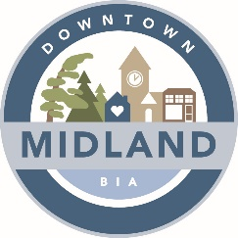

AGENDA

DOWNTOWN MIDLAND BIA BOARD MEETING

October 5th, 2021 6:30pm

Zoom Meeting - Meeting ID: 664 669 8566

Paula Lynn-Meridis |  | Susan Canning |  | Colin Pape
Karen Shepherd |  | Scott Campbell |  | Tanya Sajan
Jon Main |  | Christine Taylor |  | Roberta Douglas

Attendance: P=Present; A=Absent

1. CALL TO ORDER – pm

- ADOPTION OF MINUTES –
  - Motion to adopt the minutes dated September 7th, 2021
  - Motion to accept Agenda dated October 5^{h}, 2021
  - Declaration of pecuniary interest

- NEW AND GENERAL BUSINESS

- REPORTS
  - Event Committee – Matthew Shepherd
  - Marketing – Matthew Shepherd
  - Property Vacancy Committee – Matthew Shepherd
  - Expansion – Scott Campbell
  - Chair – Scott Campbell
  - Councilor/Town Liaison – Jon Main
  - Façade Improvement Committee – Karen Shepherd
  - Streetscape Committee – Paula Lynn-Meridis
  - Treasury – Tanya Sajan

- ADJOURNMENT – Meeting adjourned at pm.

NEXT BOARD MEETING:

November 2nd, 2021 – 6:30pm – TBD: Grounded Coffee Company (538 Bay Street) OR Zoom Meeting

