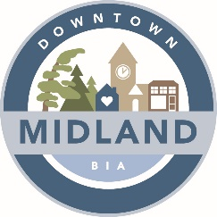

AGENDA

DOWNTOWN MIDLAND BIA BOARD MEETING

May 3, 2022 6:30pm

Zoom Meeting - Meeting ID:

Paula Lynn-Meridis |  | Susan Canning |  | Colin Pape
Kariane Copeland |  | Scott Campbell |  | Tanya Sajan
Jon Main |  | Christine Taylor |  | Roberta Douglas

Attendance: P=Present; A=Absent

1. CALL TO ORDER – pm

- ADOPTION OF MINUTES –
  - Motion to adopt the minutes dated April 5th, 2022
  - Motion to accept Agenda dated May 3rd, 2022
  - Declaration of pecuniary interest

- NEW AND GENERAL BUSINESS
  - Butter tart festival judge
  - Movie night
  - Alley way painting, benches
  - Info from OBIA convention
  - Gift certificates shop midland
  - Snow flakes little lake
  - Parking

- REPORTS
  - Event Committee – Christine Wilkie
  - Marketing –Karen Shepherd / Christine Wilkie
  - Property Vacancy Committee – Karen Shepherd
  - Expansion – Scott Campbell
  - Chair – Scott Campbell
  - Councilor/Town Liaison – Jon Main
  - Façade Improvement Committee – Paula Lynn-Meridis
  - Streetscape Committee – Paula Lynn-Meridis
  - Treasury – Tanya Sajan

- ADJOURNMENT – Meeting adjourned at pm.

NEXT BOARD MEETING:

June 1st, 2022 – 6:30pm – TBD: Grounded Coffee Company (538 Bay Street) OR Zoom Meeting

